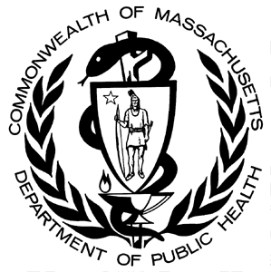

**Number of Unintentional1 Opioid2 Overdose Deaths by County, MA Residents, 2000-20143**

*Massachusetts Department of Public Health, Office of Data Management and Outcomes Assessment ● January 2016*

|  |  |  |  |  |  |  |  |  |  |  |  |  |  |  |  |  |
| --- | --- | --- | --- | --- | --- | --- | --- | --- | --- | --- | --- | --- | --- | --- | --- | --- |
| **County** | **Year of Death** | | | | | | | | | | | | | | | |
| **2000** | **2001** | **2002** | **2003** | **2004** | **2005** | **2006** | **2007** | **2008** | **2009** | **2010** | **2011** | **2012** | **2013** | **20143** | **Total  2000-2014** |
| Barnstable | 12 | 17 | 17 | 14 | 16 | 17 | 19 | 29 | 21 | 20 | 19 | 15 | 22 | 40 | 48 | 326 |
| Berkshire | 2 | 3 | 0 | 2 | 3 | 9 | 1 | 8 | 3 | 8 | 3 | 6 | 15 | 21 | 24 | 108 |
| Bristol | 37 | 56 | 60 | 80 | 67 | 75 | 79 | 61 | 78 | 66 | 74 | 76 | 92 | 111 | 134 | 1,146 |
| Dukes | 1 | 0 | 1 | 0 | 0 | 2 | 0 | 3 | 1 | 1 | 0 | 0 | 0 | 1 | 5 | 15 |
| Essex | 41 | 58 | 44 | 74 | 61 | 73 | 83 | 85 | 52 | 69 | 48 | 54 | 85 | 111 | 182 | 1,120 |
| Franklin | 5 | 2 | 1 | 5 | 3 | 4 | 6 | 4 | 2 | 2 | 4 | 6 | 8 | 9 | 11 | 72 |
| Hampden | 30 | 36 | 34 | 44 | 26 | 33 | 42 | 38 | 43 | 45 | 46 | 42 | 51 | 68 | 52 | 630 |
| Hampshire | 5 | 5 | 4 | 10 | 8 | 2 | 9 | 12 | 10 | 9 | 10 | 9 | 10 | 28 | 20 | 151 |
| Middlesex | 56 | 76 | 77 | 102 | 96 | 109 | 106 | 101 | 104 | 113 | 90 | 118 | 106 | 142 | 238 | 1,634 |
| Nantucket | 0 | 0 | 0 | 0 | 0 | 0 | 0 | 1 | 0 | 1 | 1 | 0 | 0 | 1 | 11 | N/A4 |
| Norfolk | 24 | 39 | 34 | 36 | 37 | 49 | 46 | 53 | 67 | 64 | 55 | 59 | 65 | 79 | 108 | 815 |
| Plymouth | 22 | 24 | 27 | 42 | 24 | 35 | 47 | 49 | 45 | 46 | 39 | 60 | 54 | 83 | 97 | 694 |
| Suffolk | 44 | 79 | 75 | 93 | 73 | 62 | 106 | 101 | 67 | 91 | 60 | 79 | 82 | 105 | 127 | 1,244 |
| Worcester | 59 | 73 | 55 | 47 | 42 | 55 | 71 | 69 | 68 | 64 | 77 | 79 | 78 | 112 | 126 | 1,075 |
| **TOTAL DEATHS** | **338** | **468** | **429** | **549** | **456** | **525** | **615** | **614** | **561** | **599** | **526** | **603** | **668** | **911** | **1,173** | **9,035** |

1Unintentional poisoning/overdose deaths combine unintentional and undetermined intents to account for a change in death coding that occurred in 2005. Suicides are excluded from this analysis.

2 Opioids include heroin, opioid-based prescription painkillers, and other unspecified opioids.

3 Please note that 2014 death data are preliminary and subject to updates. Case reviews of deaths are evaluated and updated on an ongoing basis. A large number of death certificates have yet to be received from the municipalities and some have yet to be assigned cause-of-death codes. These counts are based on the estimates rather than confirmed cases. Data updated on 12/10/2015.

4 Numbers and calculations based on values less than 5 are suppressed for years in which the death file is not yet closed if they are based on pending cases. The 1 death listed in Nantucket county is a confirmed opioid overdose death.

**Please note that there is rounding of counts for 2014.**

**Technical Notes:**

1. Cases were defined using the International Classification of Disease (ICD-10) codes for mortality. The following codes were selected from the underlying cause of death field to identify poisonings/overdoses: X40-X49, Y10-Y19. All multiple cause of death fields were then used to identify an opioid-related death: T40.0, T40.1, T40.2, T40.3, T40.4, and T40.6.
2. This report tracks all opioid-related overdoses due to difficulties in reporting heroin-associated overdoses separately. Many deaths related to heroin are not specifically coded as such due to the fast metabolism of heroin into morphine.
3. To maintain consistency with NCHS reporting, we do not include the ICD-10 code F11.1, which may include opioid-related overdose death.

**Source: Registry of Vital Records and Statistics, MDPH**

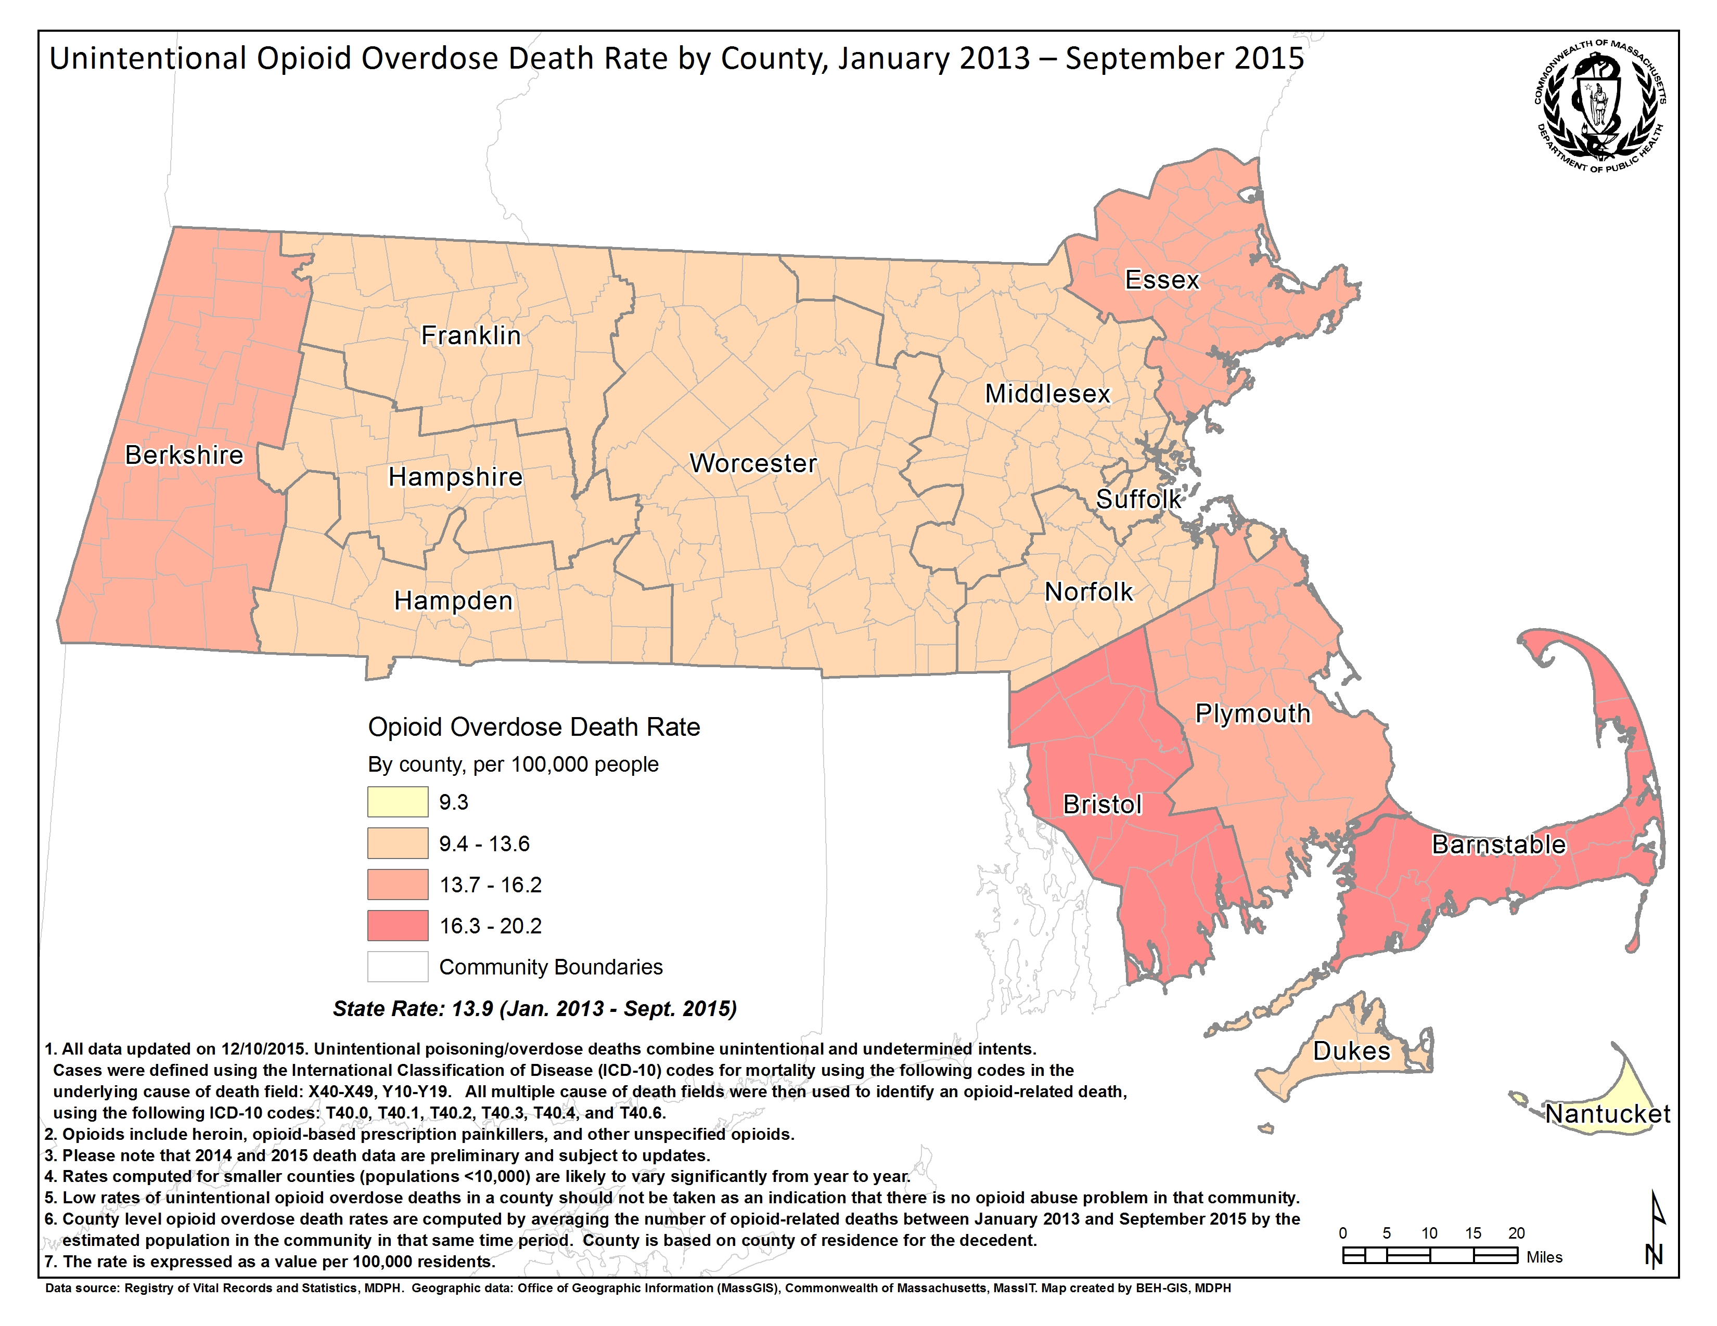

**Technical Notes**

1. Cases were defined using the International Classification of Disease (ICD-10) codes for mortality. The following codes were selected from the underlying cause of death field to identify poisonings/overdoses: X40-X49, Y10-Y19. All multiple cause of death fields were then used to identify an opioid-related death: T40.0, T40.1, T40.2, T40.3, T40.4, and T40.6.
2. This report tracks all opioid-related overdoses due to difficulties in reporting heroin-associated overdoses separately. Many deaths related to heroin are not specifically coded as such due to the fast metabolism of heroin into morphine.
3. To maintain consistency with NCHS reporting, we do not include the ICD-10 code F11.1, which may include opioid-related overdose deaths.
4. Please note that there is rounding of counts for 2014.

**Source: Registry of Vital Records and Statistics, MDPH**